Abstract Title (Times New Roman 14, Bold, Centered, Title case)

A. Author¹, B. Author^{1, 2}, C. Author³ (Times New Roman 11, Bold, Centered)

¹Full address of the first author, country (Times New Roman 10, Italic, Centered)
²Full address of the second author (Times New Roman 10, Italic, Centered)
³Full address of the third author, including country (Times New Roman 10, Italic, Centered)

Index terms: maximum four terms related to the Workshop Topics (Times New Roman 11 pts.)

The abstract, written in English, must be self-consistent and must contain original and relevant results. MS Word document (.doc) formats are accepted. Times New Roman 11 pts. justified will be used for the abstract body, single line spacing, with 0 pts spacing before and after paragraphs. Tab stops will be 1 cm.
The submissions should be no longer than one A4 page with all margins of 2.5 cm.
Figures, tables, and equations could be included.
Equations must be right aligned and numbered consecutively between parentheses, as in the following example. The line spacing before and after the equation line must be 6 pts. Sizes of characters in equations will be: full-11pts.; subscript/superscript-6.5pts.; sub-subscript/superscript-4.5pts.; symbol-16.5pts.; sub-symbols-11pts.
, (1)
For the tables, use the simplest available format. Table captions will be centered, Times New Roman, 10 pts., Bold. The line spacing before the table and after the table caption must be 6 pts.
Year | 1999 | 2009
Number of Students | 3 482 | 12688
Research Funding | 100 000 EUR | 2 500 000 EUR
Building Floor Area | 11 600 m² | 56 000 m²
Campus Area | 35 000 m² | 360 000 m²
Table I: Evolution of Stefan cel Mare University during one decade by numbers
Figure captions will be centered, Times New Roman, 10 pts., Bold. The line spacing before the Figure and after the Figure captions must be 6 pts.
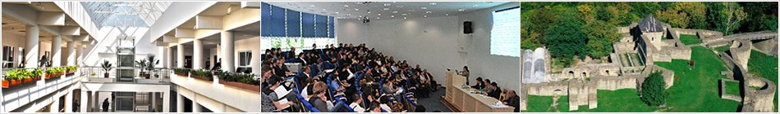
Figure 1 Atrium of Stefan cel Mare University (left) and Suceava Fortress (right)
Acknowledgements: Acknowledgements (Times new Roman, 11 pts.) can be added before references, preceded by the term “Acknowledgements” Times new Roman, 11 pts., bold.
References (Times new Roman, 11 pts) should be preceded by the term “References”, Times new Roman, 10 pts., bold. Please use no more than 5 references. They must be numbered consecutively in the text [1] using brackets and must fit the following format. Leave a free line between the main text and references.

References
[1] A. Author, B. Author, C. Author, Journal Title, first page (year)
[2] A. Author, Book Title, Publisher, Country (year)

